**Introduction**

Face detection and recognition are two related technologies that have become increasingly prevalent in recent years, thanks to advances in computer vision, artificial intelligence, and machine learning. In this article, we will explore the basics of face detection and recognition, their underlying technologies, their applications, and their potential risks and ethical considerations.

**Face Detection**

Face detection is the process of locating human faces in digital images or videos. This is typically done using a combination of image processing techniques, machine learning algorithms, and statistical models. The goal of face detection is to identify the presence and location of a face in an image or video frame, regardless of the position, orientation, or size of the face.

The most basic approach to face detection involves analyzing the color and texture of an image or video frame and looking for patterns that resemble a human face. This can be done using simple image processing techniques such as thresholding, edge detection, and template matching. However, these methods are limited in their accuracy and may fail to detect faces in complex or cluttered environments.

More advanced approaches to face detection involve machine learning algorithms that can learn to recognize patterns and features that are characteristic of human faces. These algorithms are typically trained on large datasets of labeled images, where the location and boundaries of the faces are known. The algorithms learn to identify common features of faces, such as the eyes, nose, and mouth, and can use this knowledge to locate faces in new images or video frames.

There are several different types of machine learning algorithms that can be used for face detection, including support vector machines (SVMs), neural networks, and convolutional neural networks (CNNs). SVMs are a type of supervised learning algorithm that can be trained to classify images as containing faces or not. Neural networks and CNNs are more complex algorithms that can learn to recognize faces by analyzing the underlying features of an image, such as edges, shapes, and textures.

In recent years, deep learning techniques have become increasingly popular for face detection. These techniques involve using deep neural networks that can learn to extract high-level features from images and use them to locate faces. One example of a deep learning technique for face detection is the Viola-Jones algorithm, which uses a cascade of classifiers to detect faces in real-time.

**Face Recognition**

Face recognition is the process of identifying a person by comparing their facial features with a pre-existing database of faces. This is done by analyzing the unique features of a person's face, such as the shape of their eyes, the size of their nose, and the contours of their cheeks.

Face recognition involves several different steps, including face detection, face alignment, feature extraction, and classification. The first step is face detection, which involves locating the face in an image or video frame. The second step is face alignment, which involves adjusting the face to a standardized position and orientation. This step is important for ensuring that the facial features can be accurately compared.

The third step is feature extraction, which involves extracting the unique features of a person's face. This can be done using various techniques, such as principal component analysis (PCA), linear discriminant analysis (LDA), or local binary patterns (LBP). These techniques extract the most important facial features and create a feature vector that can be used for comparison.

The final step is classification, which involves comparing the feature vector of a person's face with the feature vectors of faces in a pre-existing database. This can be done using various techniques, such as nearest neighbor, support vector machines (SVMs), or deep neural networks. The goal of classification is to identify the person whose face matches the feature vector with the highest degree of accuracy.

**Applications of Face Detection and Recognition**

Face detection and recognition have many practical applications in various fields, including security and surveillance, biometric identification, marketing and advertising, and entertainment

**OpenCV**

OpenCV (Open-Source Computer Vision Library) is a popular open-source computer vision library that provides developers with tools for image and video processing, object detection, and machine learning. OpenCV was originally

developed by Intel in 1999, and since then, it has been constantly updated and improved by a large community of developers.

OpenCV provides interfaces for various programming languages, including C++, Python, and Java. However, Python has become one of the most popular languages for using OpenCV due to its simplicity and ease of use. The Python interface to OpenCV provides a set of functions and tools that can be used to perform a wide range of image and video processing tasks, such as image filtering, image segmentation, feature detection, and object tracking.

To use OpenCV in Python, developers need to install the OpenCV library and the Python bindings. The easiest way to do this is by using a package manager such as pip. Once installed, developers can import the OpenCV library into their Python scripts and start using its functions and tools.

**Feasibility Study**

OpenCV provides several face detection algorithms, and the selection of a suitable algorithm depends on the lighting conditions, the size of the face, and the speed required for the application.

To recognize faces, the system should be trained on a dataset of images of individuals. The dataset should be large enough to cover different poses, expressions, and lighting conditions.

OpenCV provides several face detection algorithms, and the selection of a suitable algorithm depends on the lighting conditions, the size of the face, and the speed required for the application.

The system should be designed to maintain privacy and security, including protecting the facial data of individuals.

A feasibility study assessing the hardware requirements, data requirements, face detection, and recognition algorithms, privacy, security and maintenance considerations, and scalability must be undertaken before embarking on a project.

**Methodology**

Gary Bradski proposed the idea of OpenCV, which could operate on a multi-level architecture. OpenCV contains a number of noteworthy features and conveniences that are immediately apparent. The OpenCV assists in identifying a person's frontal face and also generates XML documents for various places, such as body parts.

Deep learning has advanced recently in the creation of recognition systems. As a result, face recognition and deep learning function as a deep metric learning system. In essence, face detection and identification using deep learning will primarily focus on two areas: -

the first is accepting the solidary input image or any other relevant picture, and the second is providing the best outputs or results for the image of the picture.

Python has demonstrated to produce the finest results in face recognition and detection systems. Python is a highly sophisticated programming language that is utilised all over the world. The Python programming language plus OpenCV make it incredibly simple and effective to recognise and identify faces.

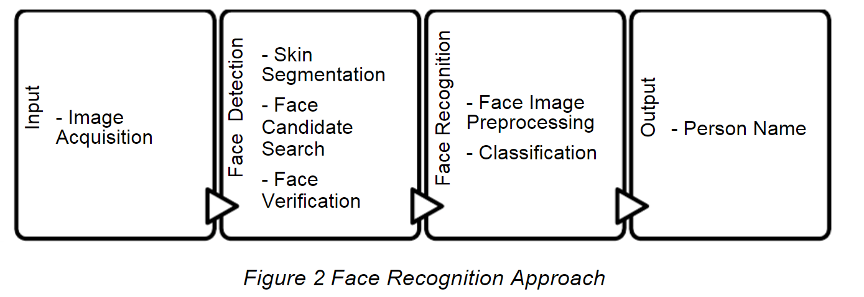

Fig 1 face recognition system approach

A face recognition system requires the input component. The picture acquisition process is completed in this section. Live pictures are transformed to digital data so that image-processing operations may be carried out on them. A face detection algorithm receives these collected photos. For the face recognition system, face detection handles face picture extraction and location tasks.

Figure provides the algorithm's face detection component. To identify the individual in the database, the updated face picture acquired by the facial recognition system must be categorized. The pre-processing of the face picture, vectorization of the image matrix, creation of the database, and classification make up the face recognition portion.

**Facilities required for proposed work**

**Hardware Requirements**

* Camera: A high-resolution camera with good image quality and adequate lightening is required in a face recognition system. The camera should be able to capture clear, high-quality images of the subject’s face from different angles and distances.
* Processor: A multi-core processor is recommended for faster processing.
* Memory: Sufficient memory to store and manipulate large amount of data is required.
* GPU: A dedicated graphics processing unit (GPU) can improve the speed and accuracy of face recognition algorithms.
* Storage: Adequate storage capacity is necessary to store large database of faces for recognition.
* Network connectivity: A high-speed network connection is essential for remote access and sharing of face recognition data.
* Power supply: The system should have a reliable and uninterrupted power supply to ensure continuous operation.
* RAM: A minimum of 4 GB of RAM is recommended, but higher RAM capacity will be better for larger datasets or more complex algorithms.
* Display: A display to monitor the system’s performance and output during operation.
* Security: The system should have robust security features to prevent unauthorized access and to protect sensitive data.

**Software Requirements**

* Operating system: OpenCV is compatible with Windows, Linux, macOS, and other platforms.
* Python: OpenCV can be used with Python, so a compatible version of Python will be required.
* OpenCV library: The OpenCV library will need to be installed on your system. You can install it using package managers such as pip or conda, or by building it from source code.
* Integrated Development Environment (IDE): You can use any text editor or IDE that supports Python, such as PyCharm, Spyder, or Visual Studio Code.

**Bibliography**

1. Activity recognition-Wikipedia,” [Online]. Available: https://en.wikipedia.org/wiki/Activity_recognition.
2. “Human Activity Recognition,” [Online]. Available: https://www.frontiersin.org/articles/10.3389/frobt.2015.00028/full.
3. “Research-Wikipedia,” [Online]. Available: https://en.wikipedia.org/wiki/ Research.
4. “Software Requirements,” [Online]. Available: <https://www.tutorialspoint.com/software_engineering/software_requirements.htm>.
5. “Flowchart-Wikipedia,” [Online]. Available: https://en.wikipedia.org/ wik i/Flowchart.
6. “Residual Neural Network-Wikipedia,” [Online]. Available: <https://en.wikipedia.org/wiki/Residual_neural_network>.
7. “Overview of Resets,” [Online]. Available: https://towardsdatascience.com /an-overview-of-resnet-and-its-variants-5281e2f56035.
8. “CNN-Wikipedia,” [Online]. Available: <https://en.wikipedia.org/wiki/Convolutional_neural_network>.
9. “Python Features,” [Online]. Available: <https://www.javatpoint.com/python-features>.
10. “Advantages and Disadvantages of Python,” [Online]. Available: <https://medium.com/@mindfiresolutions.usa/advantages-and-disadvantages-of-python-programming-language-fd0b394f2121>.
11. “Software Testing Overview,” [Online]. Available: https://www.tutorialspoint.com/software _engineering/software_testing_overview.htm.
12. “User Interface Modelling,” [Online]. Available: <https://en.wikipedia.org/wiki/User_interface_modeling>.